OSUN STATE OF NIGERIA
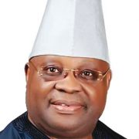
Ademola Nurudeen Jackson Adeleke
Governor
Ademola Nurudeen Jackson Adeleke is a Nigerian politician and businessman, who has served as governor of Osun State since 2022. He was the senator that represented the Osun-west senatorial district from 2017 to 2019. He is from the Adeleke family of Ede in Osun State.

Deputy Governor
Kola Adewusi is a Nigerian politician who has served as deputy governor of Osun State since 2022. Adewusi was elected deputy governor in the 2022 Osun State gubernatorial election State of Osun Official Website (osunstate.gov.ng) – 05 March 2023 – 14:54:00

