Governor
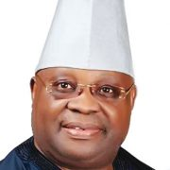
Ademola Nurudeen Jackson Adeleke is a Nigerian politician and businessman who has been serving as the governor of Osun State since 2022. He was the senator who represented the Osun-West senatorial district from 2017 to 2019. He is from the Adeleke family of Ede in Osun State.

Deputy Governor

Kola Adewusi is a Nigerian politician who has been serving as the deputy governor of Osun State since 2022. Adewusi was elected deputy governor in the 2022 Osun State gubernatorial election. He was the Local Government Chairman, Ife East, Ile-Ife, during the past government of Governor Olagunsoye Oyinlola’s regime.

